UNID: 17425095

NAME: ROJAL PRADHAN

GitHub link:

**Contents**

**Introduction 2**

**Design 2**

**Page load speed and Navigation system 5**

**Progress report 6**

**Validation 9**

**Conclusion 9**

# Introduction

When I have was starting to create this website I took some suggestion with the teachers and my friends so that they can give me an idea to design the layout of my webpage. I also searched the internet to look for some ideas. I also have to take care of not to put any JavaScript codes because it restricted in this assignment. I talked to some of our family members so that they can give me an idea. I wanted to keep my website look simple and it should only have CSS and HTML. I also looked some of the website that I have created at past and got some idea of my website should it be and what content it should have. After thing and making a rough sketch I have decided to start make my new website.

# Design

The Design of my homepage

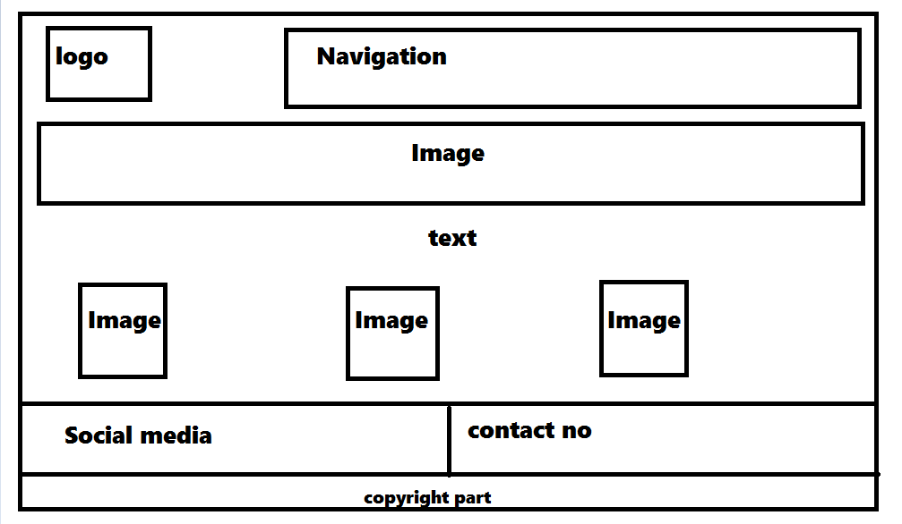

This was my rough sketches of homepage. It included a logo, navigation system, a collection of images, some welcome text, social media connection, contact no and the copyright part. Every page had their own logo thinking that I thought why don’t I create I represent my own logo that represent me. I have noticed that navigation system is most need part for the user to use my website more easily. I also put the navigation in the images which can navigate to different pages. The people who wants to contact or want more information can able to know me from the contact no or social media service. And last but not least is the copyright which is at the bottom of every page.

The Design of Bio

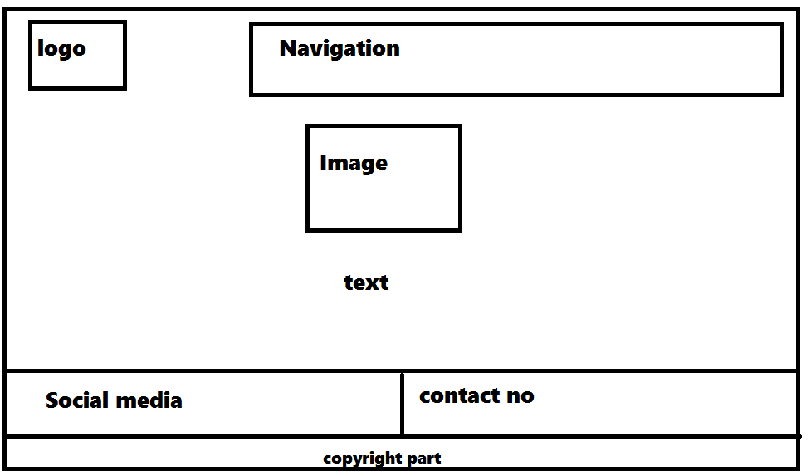

I thought to keep the header and footer part same in all of the pages and I only thought to change the section/middle part. Section have some text which explains some the things related to myself and my connection to IT. It also have my image so that the user know how I really look like.

The Design of Gallery

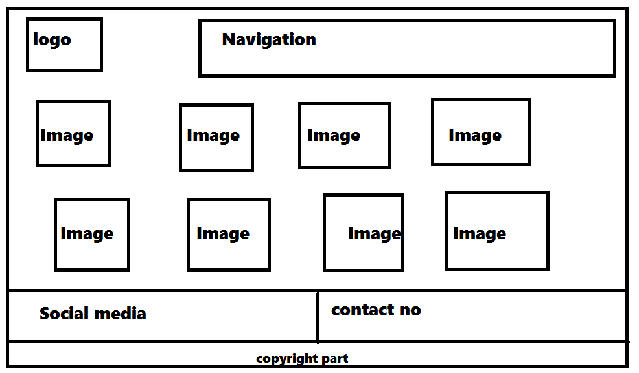

When I thought of collection of images this rough sketch came to my mind. As I already thought that I would only change the section part so Why not I keep lots of images and put some animation with coding. So I picked some of images so that I can put that in my websites.

The Design of Contact

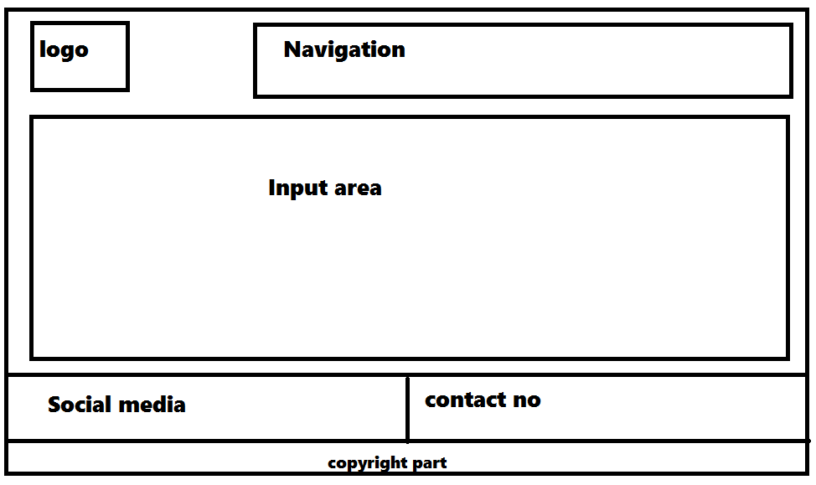

I want to keep my webpage simple so that the user won’t get any problem while using my website. There is only change in section area where I have put the Input area so that people can give some review, problems in the website, new ideas etc.

# Page load speed and Navigation system

Page Load Speed

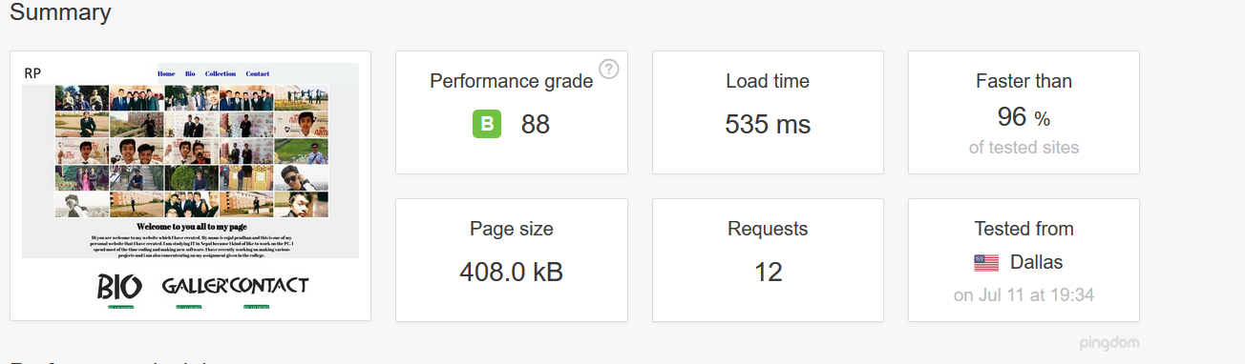

The picture above shows the loading speed of my website. It shows that my load speed 535ms which is faster and more reliable than other pages. It is faster than other 96% other sites which is been tested. My page size is also less which is only 408 kb. In summary it is quicker, better and reliable website for the users.

Navigation

The navigation is the most important part of the website because the user who are searching for some content can go only through proper navigation. My website have two navigation in the homepage one at the top and next are at the section part. When they click on the navigation at the top the can navigate to other pages. They can also navigate thought the read more button on the section part.

# Progress report

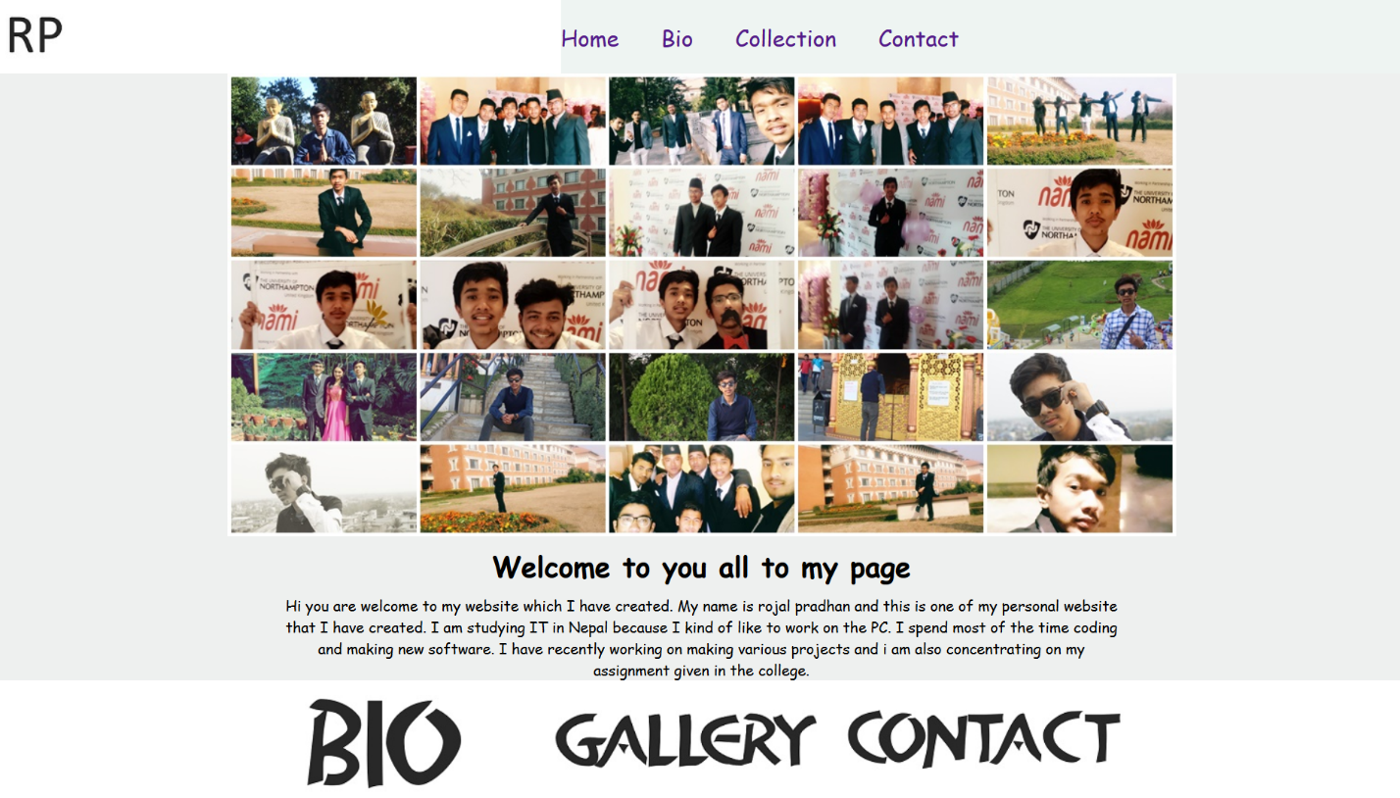

First I have created the logo “RP” is the initial of my name. Then I have choose the color for the website. I have done everything as I thought in the design. The navigation part have some animation which increase the size of font when hovered. The collage that I have created which give a certain representation of life in short to the users. I have set the image in center to look more beautiful. The welcome text part welcomes for visiting my website to all users and give my short introduction. The images of bio, contact, gallery has a read more button which navigates the users to their respective webpages.



After finishing up to the section part of home page I focused on the footer part. So I looked at design that I have created and try to keep it simple. The footer part have the logo of Instagram, Facebook which will navigate the user to my profile of social media. The Copyright part is at the bottom of the page.

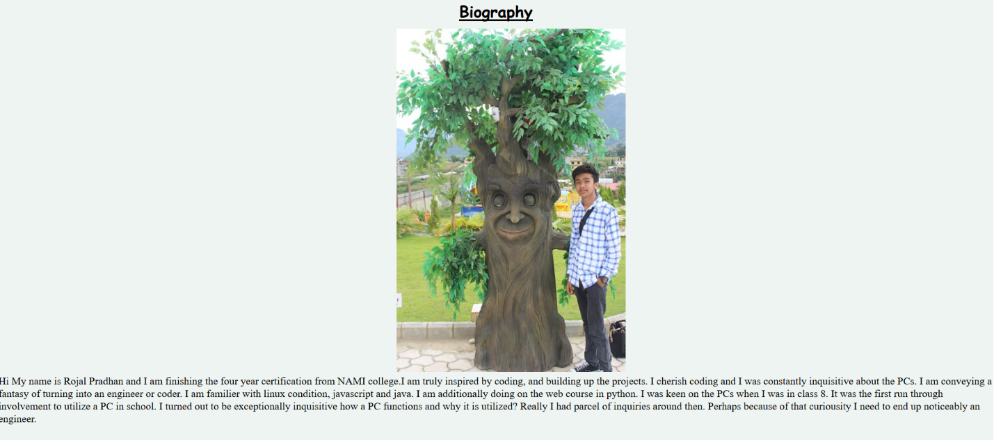

I have kept the same header and footer. I have changed the section part and kept an image of mine and gave a short biography that How I joined or how I was interested in IT. The text part will give a shadow type of animation when hover.

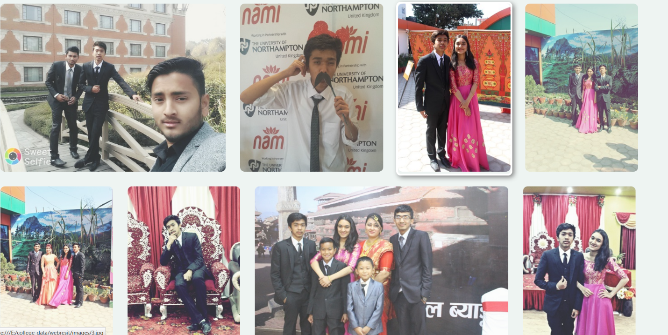

The collection of images was something new to create so I kept some border radius to make the image more attractive and kept in opacity .8 and when it hover as it shown in 3rd image above the opacity change to 1 and give a white border which attracts and looks beautiful in the webpage. I tried to keep my website simpler and less colorful.

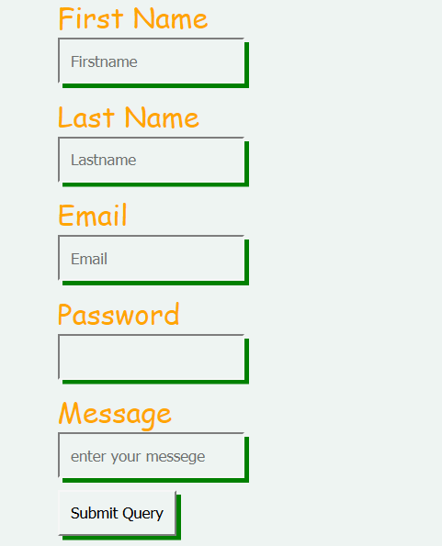

At last I have created this contact form for the users so that they can use it to give some suggestion, problems and to give notification about this website. This contact form have box shadow using place holder inside the box. The user show put their email id if they have anything to say.

# Validation

HTML

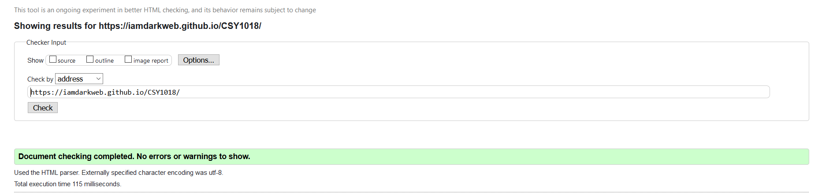

The validation check done from the W3 validation check which shows no error in html.

CSS

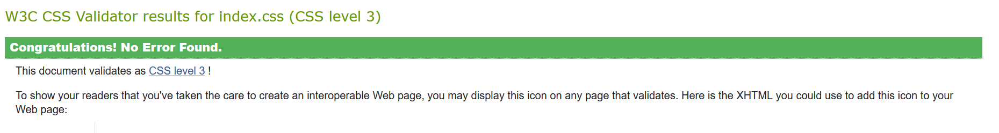

The validation check done from the W3 validation check which shows no error in CSS.

# Conclusion

After the completion of this website I noticed that some of the features could be added or be more satisfying using JavaScript which was restricted. But I was more surprised and satisfied after the completion of this website because it was created from pure HTML and CSS. The things that make my website similar are the things which the most need part in every website like mobile view, navigation, logo, social media connection. The review of my family and friends was nice which is a great thing for this website and It can more modified and can be better if more features could be added. After completion of this the practice of making website has been increased and I am looking to make this website better and satisfying for the users in the future.